

**Enhancing Long-Range Communication for Unmanned Surface Vessels in Marine Environments**

A Report

Submitted In Partial Fulfilment Of

The Requirements for the Degree Of

**BACHELOR OF SCIENCE**

In

computer science,

in the

department of Electrical Engineering, Computer Engineering and Informatics

frederick university

by

**Andreas Malathouras**

12 June 2023

Supervisor: Dr. George Demetriou

# Abstract

This report addresses the challenge of establishing effective long-range communication solutions for Unmanned Surface Vessels (USVs) operating in demanding marine environments. The objective is to identify suitable communication methods to overcome the inherent challenges of USV communication. The research evaluates extended WiFi connectivity through private networks and assesses its feasibility. The study underscores the importance of robust communication networks for autonomous maritime systems and highlights existing knowledge gaps. Various communication methodologies are explored using the Raspberry Pi platform for implementation, including cellular networks, point-to-point (PTP) WiFi connections with directional antennas, and LoRa communication.

Notably, the implementation includes a directional point-to-point link for enhanced range, mounted on a dual-axis robotic arm capable of tracking the vessel at long distances using LoRa. The practical implications of these methodologies are analyzed through simulations, lab tests, and field trials, providing insights into their effectiveness and reliability in marine environments. This comprehensive approach ensures a thorough evaluation of the proposed communication solutions, offering practical insights and potential applications for improving USV communication systems in challenging maritime settings.

# Table of Contents

Abstract 2

Table of Contents 3

Chapter 1 – Introduction 5

1.1. Basis and Rationale of the Project Proposal 6

1.2. Validation and Evaluation 6

Chapter 2 – Literature Review 8

2.1. Understanding Communication Challenges in Marine Environments 8

2.2. Exploring Communication Methodologies 9

2.3. Evaluating Communication Performance Metrics 9

2.4. Analyzing Communication Options for Unmanned Surface Vehicles (USVs) 10

2.4.1 Wireless Communication Options: 11

2.4.2 Latency Comparison Table: 12

2.4.3 Cost Comparison Table: 13

2.4.4 Reliability and Redundancy Comparison Table: 14

2.4.5 Regulatory and Licensing Comparison Table: 15

2.5. WiFi Antenna Radiation Models and Radiation Shapes 16

2.5.1 Isotropic Antennas: 16

2.5.2 Dipole Antennas: 16

2.5.3 Yagi-Uda Antennas: 17

2.5.4 Parabolic Antennas: 18

2.6. Proposed System Design 19

2.6.1 2.4GHz WiFi Directional to Omnidirectional Link: 20

2.6.2 Dual-Axis Gimbal for Antenna Control: 20

2.6.3 Lost Link Handling: 20

2.6.4 Alternative Emergency Links via Cellular Networks: 21

2.6.5 Identifying Research Gaps and Future Directions 21

Chapter 3 – System Implementation 22

3.1 System Overview 22

3.2 System Components and Architecture 23

3.1.1 Base Station Configuration 23

3.1.2 Unmanned Surface Vessel (USV) Configuration 24

3.3 System Analysis Theoretical Limits of Communication Range 26

3.2.1 Longley Rice ITM Model 26

3.2.2 LoRa Communication 27

3.2.3 Wi-Fi Communication 27

3.2.4 System Limitations and Environmental Considerations 28

3.3 Hardware Design 28

3.4 System Design Methodology 30

3.4.1 Field Test Setup 30

3.4.2 Test Procedures 31

3.4.3 Results and Observations 32

Chapter 4 – Future Work 33

4.1 Implementation of Stepper Motors with Micro stepping 33

4.1.1 Benefits of Stepper Motors 33

4.1.2 Technical Considerations 33

4.2 Integration of RTK GPS for Enhanced Positioning Accuracy 34

4.2.1 Advantages of RTK GPS 34

4.2.2 Implementation Steps 34

4.3 Expanding Degrees of Freedom 35

4.3.1 Solving the 180-Degree Limitation 35

4.3.2 Technical Challenges 35

Chapter 5 – Conclusions 36

5.1 Summary of Findings 37

5.1.1 Key Contributions 37

5.1.2 Limitations 38

References 39

# Chapter 1 – Introduction

This thesis explores long-range communication in a marine context, focusing on establishing effective WiFi connectivity for Unmanned Surface Vessels (USVs). The central hypothesis aims to validate the feasibility of extending WiFi connectivity for USVs, specifically through point-to-point (PTP) WiFi connections using directional antennas.

The investigation's motivation arises from the need for reliable communication solutions in marine environments, where traditional methods often fall short. The chosen topic addresses the existing gap in literature regarding robust long-range communication networks for USVs in marine settings.

Upon completing the core research and receiving guidance from advisors, the introduction will be revisited to integrate the findings and implications of the investigation. This iterative process will refine the study's scope, purpose, and significance as informed by the research outcomes.

The motivation behind this specific problem proposal stems from the need to address a critical challenge in developing SeaBot, an Unmanned Surface Vessel (USV) designed for marine surveys and oil spillage analysis. The pivotal issue revolves around establishing a private, long-range communication network that enables the seamless data transmission from the onboard radar system. This challenge is paramount due to the unmanned nature of the SeaBot, which inherently relies on robust telemetry transmission for effective operations. The radar's WiFi-based application further amplifies the need for a reliable communication solution. It is crucial to solve this challenge to ensure the vessel's functionality and maintain its potential to contribute to marine surveying and environmental monitoring.

This project aims to investigate various communication methodologies comprehensively, evaluating their suitability for addressing the challenge above. By delving into the realm of communication methods, the project intends to determine the most appropriate approach that aligns with the specific usage context of SeaBot. Among the potential solutions to be explored are cellular networks, point-to-point (PTP) WiFi networks utilizing directional antennas, and Long-Range (LoRa) communication. This research-driven approach ensures that the chosen communication method supports the radar system's data transmission needs and aligns with the vessel's operational requirements and overall objectives. Through systematic analysis and comparison, the project aims to provide practical insights that guide selecting and implementing an optimal communication strategy for SeaBot's marine surveys and oil spillage analysis.

## Basis and Rationale of the Project Proposal

The present subsection establishes the underlying rationale for the project proposal, drawing from pertinent references to substantiate the motivation and problem context.

The core problem to be addressed is establishing a private long-range communication network for SeaBot, an Unmanned Surface Vessel (USV) developed for marine surveys and oil spillage analysis. The project's importance arises from the inherent challenges of achieving reliable communication in maritime environments for autonomous vehicles. SeaBot's unmanned nature demands a robust telemetry system for remote control and data transmission. At the same time, its onboard radar, critical for marine survey and oil spillage analysis, necessitates a practical and secure means of data transfer.

Relevant literature provides valuable insights into this challenge. Min et al. (2015) propose an active antenna tracking system with directional antennas to enhance wireless communication capabilities in networked robotic systems. This approach aligns with the project's focus on directional antennas for improved connectivity in marine contexts [1].

Additionally, Pensieri et al. (2021) delve into evaluating LoRaWAN connectivity in a marine scenario, offering insights into the feasibility of employing Long-Range (LoRa) communication technology, which is particularly relevant to the project's exploration of communication methods [2]. These references underscore the significance of the communication challenge and contribute to the project's approach of exploring existing solutions and methodologies in related domains.

## Validation and Evaluation

The final subsection outlines the planned validation and evaluation methodology for testing the project's outcomes, along with the chosen platform for implementation and the rationale behind this selection.

**Validation and Evaluation Methodology:**

The proposed validation and evaluation process will comprise several stages to comprehensively assess the effectiveness of the established communication solution for SeaBot.

1. **Simulation and Testing:** Initial testing will involve simulated scenarios to evaluate the communication method's performance under controlled conditions. This will enable the assessment of connectivity, data transfer rates, and system responsiveness.
2. **Laboratory Testing:** The next phase will transition to laboratory testing using a controlled environment. Actual hardware components, including the onboard radar and communication modules, will be utilized to assess the system's real-world functionality.
3. **Field Trials:** Subsequent validation will entail field trials in marine settings, replicating operational conditions to assess the communication method's reliability, range, and robustness in the presence of environmental variables.
4. **Performance Metrics:** Throughout the validation stages, metrics such as latency, packet loss, and signal strength will be monitored to evaluate the communication system's performance quantitatively. Qualitative assessments, including user feedback, will also contribute to the evaluation process.

**Platform Selection and Justification:**

The Raspberry Pi platform has been chosen as the foundation for communication module integration within SeaBot for the project's implementation. The Raspberry Pi offers a balance of computational power, flexibility, and connectivity options, making it suitable for integrating communication protocols and supporting the onboard radar system.

The selection aligns with the project's emphasis on exploring various communication methods, as the Raspberry Pi provides the versatility to implement cellular networks, PTP WiFi, or LoRa solutions. Additionally, the platform's widespread adoption and community support ensure the availability of resources, and technical expertise, facilitating the seamless integration of the chosen communication method.

The Raspberry Pi's compact size, low power consumption, and compatibility with various hardware peripherals make it an ideal choice for marine-based applications where space and energy efficiency are crucial considerations. Furthermore, the platform's affordability enhances its viability for deployment in unmanned systems, like SeaBot, which often require cost-effective solutions to achieve practical viability.

# Chapter 2 – Literature Review

The literature review comprehensively explores existing knowledge and research pertinent to establishing effective long-range communication solutions for Unmanned Surface Vessels (USVs) in marine environments. This chapter seeks to elucidate the foundational concepts, methodologies, and findings from accredited scholars and researchers in the field. The literature review aims to synthesize and evaluate the available literature while identifying areas of controversy and gaps in the research. It also lays the groundwork for exploring communication methodologies, aligning with the central aim of the thesis.

## Understanding Communication Challenges in Marine Environments

Before delving into specific communication methodologies, it is imperative to comprehend the unique challenges posed by communication in marine environments. Existing literature emphasizes the significance of establishing robust communication networks for USVs operating in challenging maritime conditions. Min et al. (2015) propose the utilization of directional antennas for improved wireless communication capabilities in networked robotic systems [1]. This aligns with the project's focus on directional antennas for long-range communication in marine settings.

Alqurashi et al. (2023) present a comprehensive survey on maritime communications, encompassing enabling technologies, opportunities, and challenges [3]. This survey provides a holistic overview of maritime communications, including radio frequency (RF) and optical bands, modulation and coding schemes, coverage and capacity, and emerging use cases such as the Internet of Ships and the ship-to-underwater Internet of Things. Their work further outlines open challenges and future research directions for maritime communication, contributing valuable insights to the field.

Hoeft et al. (2021) discuss the evolution of maritime ICT systems and the challenges posed by limitations in communication technologies in offshore areas [4]. Their exploration of the netBaltic system highlights the capability to use different communication technologies transparently to support maritime ICT services efficiently. This study enriches the literature by addressing the need for versatile and efficient communication systems in the maritime domain.

## Exploring Communication Methodologies

Exploring communication methodologies in maritime settings is essential to identify solutions for the communication challenge. Pensieri et al. (2021) evaluate the feasibility of employing Long-Range (LoRa) communication technology in marine scenarios [2]. Their study sheds light on the potential of LoRa networks for addressing communication needs in challenging environments, which aligns with the project's goal of assessing diverse communication methods.

The selection of communication platforms is crucial to establishing reliable communication links. As chosen in the project's implementation plan, the Raspberry Pi platform offers flexibility and compatibility with various communication protocols. This aligns with the research's focus on adaptable solutions catering to different communication methodologies.

## Evaluating Communication Performance Metrics

Measuring the performance of communication solutions is fundamental to assessing their viability and effectiveness. The proposed validation and evaluation methodology integrates simulation, laboratory testing, and field trials to evaluate communication performance comprehensively. The emphasis on metrics such as latency, packet loss, and signal strength resonates with established practices in assessing communication systems [3]. This approach aligns with the research's intention to provide quantitative insights into the selected communication method's performance.

## Analyzing Communication Options for Unmanned Surface Vehicles (USVs)

In the realm of Unmanned Surface Vehicles (USVs), a diverse array of communication options are available to facilitate seamless data exchange and control. These options encompass cutting-edge technologies such as satellite internet, leveraging the broad coverage and global reach of satellite networks to maintain connectivity even in remote maritime regions. Another avenue involves harnessing terrestrial cellular networks, including 3G, 4G, 5G, and LTE, which offer high data transfer rates and low latency, making them suitable for nearshore operations. Moreover, the utilization of directional to omnidirectional WiFi antennas presents an efficient means of communication within relatively shorter distances, affording flexibility in network configuration. Each of these communication alternatives presents its own distinct set of advantages and disadvantages, forming a complex landscape of choices that merit in-depth exploration and comparison to determine their feasibility and applicability in different USV scenarios.

### Wireless Communication Options:

The following table offers a comprehensive comparative analysis of various communication options for Unmanned Surface Vehicles (USVs), highlighting crucial parameters such as transmission power, range, and average transmission/reception power. In the evolving landscape of maritime technology, the selection of an optimal communication method plays a pivotal role in ensuring efficient data exchange and control for USVs.

Table I. Wireless Communications Comparison [5] [6] [7] [8] [9]

|  |  |  |  |
| --- | --- | --- | --- |
| **Communication Option** | **Mbps (Data Transfer Speed)** | **Range (km)** | **Power Consumption (W)** |
| Satellite Internet | <= 100 | Global | 50 - 75 |
| 5G Cellular Networks | 10 - 1000 | Up to 50 | 990 - 11,577 |
| 4G/LTE Cellular Networks | 10 - 100 | Up to 30 | 990 - 6,877 |
| 3G Cellular Networks | 1 - 10 | Up to 10 | 990 - 4,808 |
| WiFi (Directional Antennas) | 50 - 500 | Up to 5 | 0.1-1 |
| WiFi (Omnidirectional Antennas) | 10 - 100 | Up to 2 | 0.05 - 0.1 |
| LoRaWAN | 0.0003 - 0.05 | |  |  | | --- | --- | | 5km Urban | 15km Suburban | | 0.01 - 1 |

### 2.4.2 Latency Comparison Table:

The following table presents a comparison of latency for different communication options available to Unmanned Surface Vehicles (USVs). Latency, the time delay between data transmission and reception, is a critical factor affecting real-time control and decision-making in USV operations. The values provided in the table offer insights into the varying latency characteristics of each communication type and can aid in selecting the most suitable option for applications requiring minimal delay.

Table II. Latency Comparison [10] [11] [12] [13] [14]

|  |  |
| --- | --- |
| **Communication Type** | **Latency (ms)** |
| Satellite Internet | 20-40 |
| 5G Cellular Networks | 1 - 10 |
| 4G/LTE Cellular Networks | 10 - 50 |
| 3G Cellular Networks | 50 – 100 |
| WiFi (Directional Antennas) | Distance based |
| WiFi (Omnidirectional Antennas) | Distance based |
| LoRaWAN | Up to 400ms |

### 2.4.3 Cost Comparison Table:

In the realm of Unmanned Surface Vehicles (USVs), understanding the financial implications of different communication options is essential for informed decision-making. The subsequent table outlines a cost comparison for various communication methods. It sheds light on both initial and ongoing operating costs, providing a comprehensive view of the budgetary considerations associated with each option, enabling stakeholders to align their choices with budget constraints.

Table III. Cost Comparison [15] [16]

|  |  |  |
| --- | --- | --- |
| **Communication Type** | **Initial Cost** | **Operating Cost** |
| Satellite Internet | $499 | $99/mo |
| 5G Cellular Networks | >$5000 | High |
| 4G/LTE Cellular Networks | $1500 | Low |
| 3G Cellular Networks |
| WiFi (Directional Antennas) | ~$239 | Low |
| WiFi (Omnidirectional Antennas) | ~$320 | Low |
| LoRaWAN | $≥$ $289 | Very Low |

### Reliability and Redundancy Comparison Table:

The reliability and redundancy of communication systems are pivotal for maintaining connectivity and operational continuity in dynamic maritime environments. Presented below is a comparison table that assesses the reliability of various communication options for Unmanned Surface Vehicles (USVs). The table also highlights available redundancy options, equipping decision-makers with insights into the robustness of each communication method in challenging scenarios.

Table IV. Reliability and Redundancy

|  |  |  |
| --- | --- | --- |
| **Communication Type** | **Reliability** | **Redundancy Options** |
| Satellite Internet | High | Backup Satellite Link, Cellular |
| 5G Cellular Networks | High | Cellular, WiFi |
| 4G/LTE Cellular Networks | High | Cellular, WiFi |
| 3G Cellular Networks | Moderate | Cellular, WiFi |
| WiFi (Directional Antennas) | Moderate | Cellular, Satellite |
| WiFi (Omnidirectional Antennas) | Moderate | Cellular, Satellite |
| LoRaWAN | Low | Cellular, Satellite |

### Regulatory and Licensing Comparison Table:

Navigating the regulatory landscape is paramount when deploying Unmanned Surface Vehicles (USVs) equipped with communication systems. The forthcoming table offers an overview of the regulatory requirements and licensing considerations associated with different communication options. By understanding the regulatory nuances and licensing obligations, stakeholders can ensure compliance and adherence to legal frameworks while deploying USVs in various regions.

Table V. Licensing Requirements

|  |  |  |
| --- | --- | --- |
| **Communication Type** | **Regulatory Requirements** | **Licensing** |
| Satellite Internet | International | Licensed |
| 5G Cellular Networks | National | Licensed |
| 4G/LTE Cellular Networks | National | Licensed |
| 3G Cellular Networks | National | Licensed |
| WiFi (Directional Antennas) | Local | Unlicensed |
| WiFi (Omnidirectional Antennas) | Local | Unlicensed |
| LoRaWAN | Local | Unlicensed |

## WiFi Antenna Radiation Models and Radiation Shapes

### Isotropic Antennas:

Isotropic antennas are idealized models used as reference antennas for comparison purposes. In theory, isotropic antennas radiate electromagnetic waves uniformly in all directions, creating a spherical radiation pattern. In practice, isotropic antennas are impossible to build, but they serve as a baseline for measuring the gain and directivity of real antennas. The radiation shape of an isotropic antenna is omnidirectional, meaning it radiates equally in all azimuthal directions.

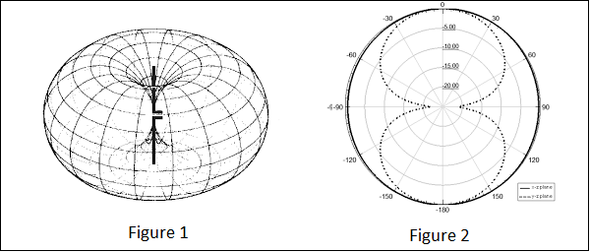

Figure I. Isotropic Radiation Pattern [17]

### Dipole Antennas:

Dipole antennas are among the simplest and most commonly used antenna types in WiFi and other wireless systems. A half-wavelength dipole antenna consists of two equal-length conductive elements, with the radiation pattern resembling a doughnut or toroid shape. This radiation pattern is bidirectional, with maximum radiation perpendicular to the antenna's axis and minimal radiation off the antenna's ends. Dipole antennas are often used for point-to-point and point-to-multipoint WiFi communication.

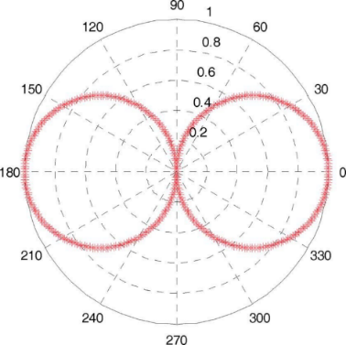

Figure II. Dipole Radiation Pattern [18]

### Yagi-Uda Antennas:

Yagi-Uda antennas, also known as Yagi antennas, are directional antennas characterized by their array of multiple dipole elements. These elements are carefully spaced and tuned to create constructive and destructive interference patterns. Yagi-Uda antennas offer high gain and directivity, making them suitable for long-range WiFi communication. Their radiation pattern is highly directional, with maximum radiation in the direction of the driven element and reduced radiation in other directions. This unidirectional pattern enhances the antenna's ability to establish strong connections over longer distances.

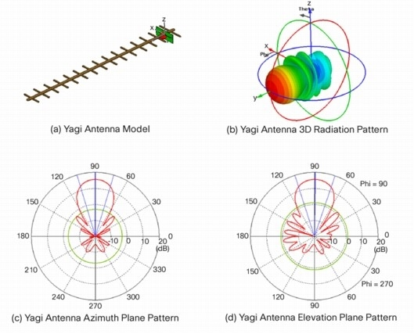

Figure III. Yagi-Uda Radiation Pattern [19]

### Parabolic Antennas:

Parabolic antennas consist of a parabolic reflector and a feed element (usually a dipole or horn antenna) placed at the focal point of the reflector. These antennas are known for their high gain and extreme directivity, making them ideal for point-to-point communication, such as long-distance WiFi links and satellite dishes. The radiation pattern of a parabolic antenna is extremely focused, with a narrow beamwidth that concentrates the energy in a specific direction.

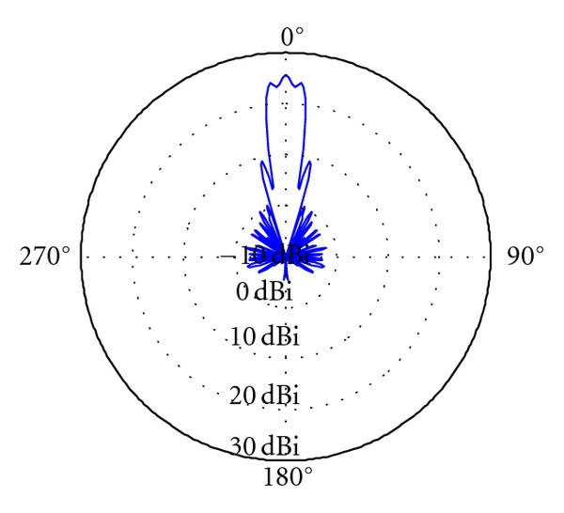

Figure IV. Parabolic Radiation Pattern [20]

## Proposed System Design

In this subsection, we propose a high-level system design that outlines the connectivity between a ground station and an Unmanned Surface Vehicle (USV) utilizing a 2.4GHz WiFi directional to omnidirectional link. The design incorporates a directional antenna controlled by a dual-axis gimbal to track the USV while it is in motion, ensuring a stable two-way connection for transmitting telemetry and radar data to the ground station. Additionally, the USV is equipped with an omnidirectional antenna, while the ground station employs a directional antenna. In the event of a link loss, the system initiates a sweep mode, and the USV autonomously navigates back to its last known good GPS location.

The diagram below provides a visual representation of the high-level system design described in the preceding subsections. It illustrates the connectivity between the ground station and the Unmanned Surface Vehicle (USV), showcasing the key components such as the 2.4GHz WiFi directional antenna with a dual-axis gimbal for tracking, the bidirectional data transmission, and the fail-safe measures involving cellular networks in case of link loss. This diagram serves as a concise and informative overview of the system architecture, highlighting the critical elements that enable robust communication and control between the ground station and the USV.

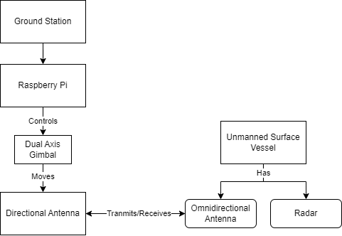

Figure V. Proposed System Design

### 2.4GHz WiFi Directional to Omnidirectional Link:

The primary communication link between the ground station and the USV is established using 2.4GHz WiFi technology. This frequency band is chosen for its balance between range and data transfer capabilities. The directional antenna on the ground station provides long-range communication, while the USV's omnidirectional antenna ensures consistent connectivity in all directions.

### Dual-Axis Gimbal for Antenna Control:

A dual-axis gimbal is employed to control the directional antenna on the ground station. This gimbal allows precise control over the antenna's orientation, enabling it to track the moving USV effectively. The gimbal's orientation is determined by processing the USV's reported GPS data and Inertial Measurement Unit (IMU) sensor data, ensuring accurate alignment with the USV's position and orientation.

### Lost Link Handling:

In the event of a lost connection, the system employs a contingency plan. The directional antenna on the ground station enters sweep mode, scanning for the USV's signal in a predefined pattern. Simultaneously, the USV utilizes its last known good GPS location as a reference point for autonomous navigation. Once the signal is reestablished, the directional antenna locks onto the USV, and normal communication resumes. This feature ensures the system's resilience and the ability to recover from temporary communication disruptions.

### Alternative Emergency Links via Cellular Networks:

In addition to the primary communication link described above, an alternative emergency communication strategy can be implemented as a fail-safe measure. In the rare event that the USV cannot retrieve the connection using the directional antenna and GPS navigation as outlined previously, cellular networks can serve as a reliable backup option. Cellular networks offer wide coverage areas and are less susceptible to the line-of-sight limitations that can affect WiFi connections over longer distances.

When the primary link is lost, the USV can automatically switch to cellular communication, allowing it to transmit critical data and receive commands from the ground station. This switch to cellular networks can provide an additional layer of redundancy, ensuring that the USV remains reachable and controllable even in challenging situations. This alternative emergency link enhances the overall reliability and safety of the communication system, guaranteeing that vital information can still be exchanged between the ground station and the USV when needed most.

### 2.6.5 Identifying Research Gaps and Future Directions

While existing literature provides valuable insights into communication challenges and potential solutions, there still needs to be a gap in exploring private, long-range communication networks tailored specifically for USVs in marine environments. The current body of work predominantly focuses on terrestrial and aerial communication systems, leaving room for further research in the maritime domain.

This study addresses this gap by investigating the feasibility, effectiveness, and practical implications of implementing private, two-way WiFi communication networks for USVs. By employing a systematic and exploratory approach, the research seeks to bridge the gap between existing knowledge and the emerging needs of autonomous maritime systems.

# Chapter 3 – System Implementation

This chapter provides a comprehensive system analysis and implementation focused on enhancing communication strategies for Unmanned Surface Vessels (USVs) in marine environments. The chapter details rigorous testing of innovative communication systems, notably comparing the efficacy of point-to-point (PTP) links, which utilize directional antennas, against traditional omnidirectional links that often suffer from interference and reduced throughput. The analysis also explores the integration of Long-Range (LoRa) networks with a dual-axis tracking system to optimize WiFi connectivity over vast maritime distances. The methodologies employed include simulations, lab tests, and extensive field trials designed to mimic the challenging marine conditions faced by USVs. Ethical considerations were meticulously followed, complying with local and EU regulations to ensure environmentally sound and non-intrusive experiments. The chapter concludes with reflections on the practical challenges encountered during fieldwork, emphasizing the importance of flexibility and thorough preparation in conducting effective marine communication research.

## System Overview

This section details the system configuration designed to enhance communication with Unmanned Surface Vessels (USVs) through a complex setup involving both a base station and the USV. The base station has a dual-axis gimbal system controlled by servo motors for precise azimuth and elevation adjustments. It incorporates an MPU9250 Inertial Measurement Unit, a BMP180 Barometer, and an MTK3339 GPS, all linked to an Adafruit Feather M0, which processes signals and controls the gimbal to direct the antenna accurately. This directional antenna is crucial for focusing Wi-Fi signals into a narrow beam, significantly improving range and signal strength for marine communication. The USV is similarly outfitted with an Adafruit Feather M0 and features a BMP180 Barometer and MTK3339 GPS for navigation and barometric data. The base station and the USV include a LoRa transceiver, facilitating robust long-range communication by sending and receiving position and telemetry data. This ensures dynamic and stable connectivity as the USV navigates through marine environments.

## 3.2 System Components and Architecture

### Base Station Configuration

**Dual-Axis Gimbal System**

The base station's dual-axis gimbal system enables precise directional control of the antenna, maintaining a focused and robust Wi-Fi signal directed toward the USV. The system uses two MG996R servos for azimuth (horizontal) and elevation (vertical) movements. It includes an MPU9250 Inertial Measurement Unit (IMU) for real-time monitoring and adjusting the antenna’s position, paired with a BMP180 Barometer for fine-tuning elevation.

**Directional Antenna**

The directional antenna enhances the Wi-Fi signal's range and strength by focusing transmissions into a narrow beam, which is essential for long-distance marine communication. This setup significantly improves the reliability and effectiveness of the communication link.

**Adafruit Feather M0**

The Adafruit Feather M0 processes LoRa packets from the USV, which contain telemetry and GPS positioning data. This processing is critical for the gimbal system's operations, ensuring the antenna remains accurately aligned with the USV.

**GPS and LoRa Modules**

The GPS module enables precise location tracking of the base station, while the integrated LoRa module ensures robust long-range communication between the base station and the USV. This integration is vital for maintaining a stable and continuous communication link.

### Unmanned Surface Vessel (USV) Configuration

**Adafruit Feather M0**

The Adafruit Feather M0 acts as the central communication hub on the USV, handling all data transmissions efficiently. This microcontroller is essential for integrating various communication components and ensuring seamless data flow.

**Integrated GPS and LoRa Module**

The integrated GPS and LoRa module combines GPS positioning with LoRa communication capabilities, which are crucial for navigation and maintaining long-range, low-bandwidth communication with the base station. This integration ensures real-time updates of the USV’s position and relevant telemetry data, supporting extended-range Wi-Fi connectivity and enhancing the overall communication system's reliability and performance.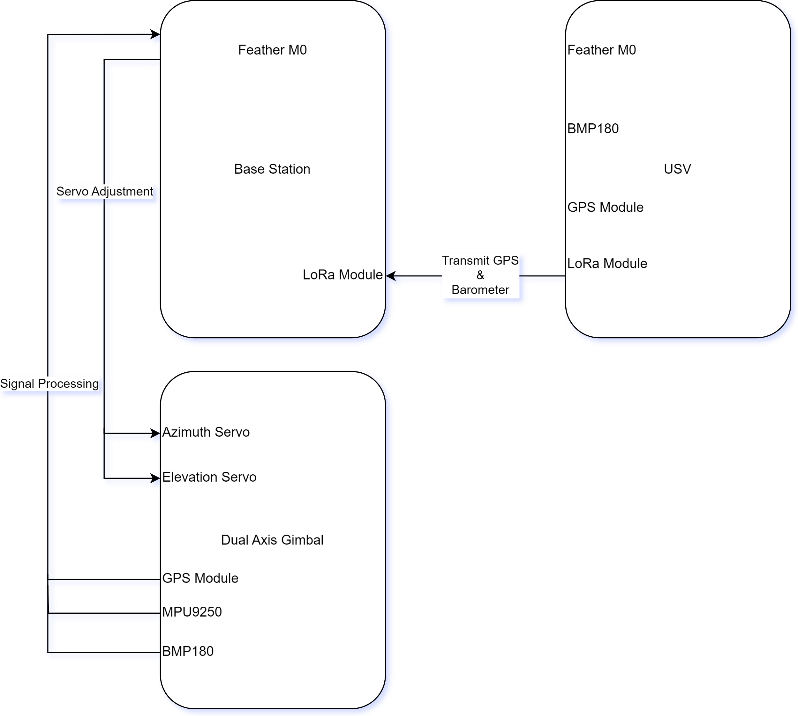

Figure VI. System UML Diagram

**System Operation:**

* **Initialization:** At startup, the base station uses its GPS, sensors, and servo mechanisms to orient the directional antenna towards an initial set location, based on the USV’s last known coordinates or a predetermined starting point.
* **Operational Dynamics:** As the USV navigates, it continually updates its location through the integrated GPS and LoRa module. The base station receives this information and adjusts the orientation of the directional antenna to maintain alignment with the USV.
* **Feedback and Adjustment Mechanisms:** The MPU9250 IMU provides orientation data for precise antenna control, while the BMP180 barometer offers additional data points for adjusting the antenna's pitch, accommodating environmental factors.

## System Analysis Theoretical Limits of Communication Range

This subsection evaluates the theoretical limits of the communication range between the base station and the Unmanned Surface Vessel (USV) using the LoRa and Wi-Fi systems integrated into both setups. The analysis incorporates the Longley Rice (ITM) model to provide a quantitative measure of how the system's design and technological choices influence its operational range, particularly in the context of marine environments. The below usage of the Longley Rice model has been used in the context of the software RadioMobile

### 3.2.1 Longley Rice ITM Model

The Longley Rice Irregular Terrain Model (ITM) is widely used for predicting radio wave propagation over varied terrain. It is particularly useful for assessing the communication range in environments with complex terrain, such as marine areas with varying land contours and vegetation. The model considers factors like terrain elevation, antenna height, and the curvature of the earth.

The fundamental equation of the Longley Rice ITM model for the signal path loss $L_{dB}$ ​ is given by:

$$L_{dB}=20\log_{10}\left(\frac{4πdf}{c}\right)+L_{h}+L_{t}+L_{e}+L_{p}$$

where:

* $d$ is the distance between the transmitter and receiver.
* $f$ is the frequency of operation in Hz.
* $c$ is the speed of light in a vacuum $\left(3×{10}^{8}\text{ m}\text{/}\text{s}\right)$
* $L_{h}$ ​ accounts for the height loss of the antennas.
* $L_{t}$ represents terrain losses.
* $L_{e}$ ​ includes the effects of environmental factors such as foliage and buildings.
* $L_{e}$ adjusts for additional propagation effects like diffraction and scattering.

Additionally, the model incorporates empirical data through the use of correction factors and terrain profiles, providing a detailed prediction of signal loss over the terrain. This approach is essential for determining the effective communication range and reliability of LoRa and Wi-Fi systems in the specified marine environment.

### LoRa Communication

The LoRa system is especially critical for long-range communication due to its ability to transmit over extended distances at low power. The sensitivity of the LoRa transceiver at 433 MHz is exceptionally high, in our configuration up to -148dBm [21], which allows for greater range. The below Radio Mobile to simulation is graphed for our theoretical results

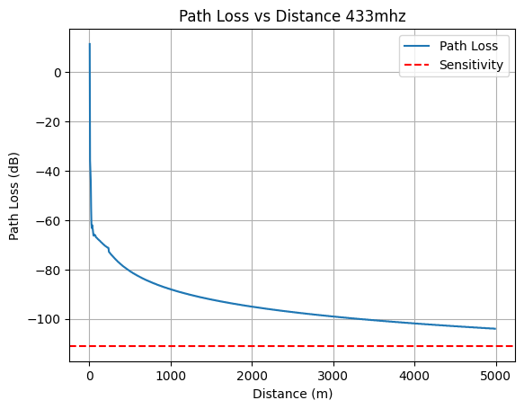

Figure VII. Simulated LoRa Propagation

### Wi-Fi Communication

For the directional Wi-Fi setup, the range is primarily enhanced by the directional antenna used at the base station, focusing the Wi-Fi signal into a narrow beam. This setup is ideal for maintaining a stable and strong connection with the USV. The below Radio Mobile to simulation is graphed for our theoretical results

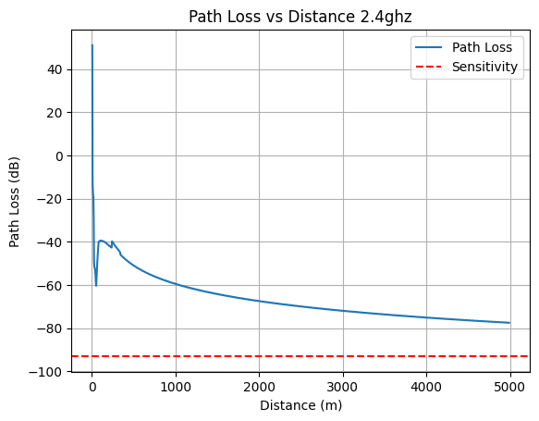

Figure VIII. Simulated WiFi Propagation

### System Limitations and Environmental Considerations

The theoretical calculations provide a baseline understanding of the maximum possible ranges. However, practical limitations such as atmospheric conditions, physical obstructions, and system noise can significantly impact actual performance. Specifically, marine environments introduce additional challenges like saltwater interference, which can affect the stability of signal reception.

The integration of high-precision components like the MPU9250 IMU and GPS systems in both the base station and the USV ensures that the system can dynamically respond to changes in environmental conditions and vessel movement, thus maintaining the effectiveness of the communication links.

## Hardware Design

In our proposed hardware design, we present comprehensive schematics for both the base station and the Unmanned Surface Vessel (USV). The base station incorporates a dual-axis gimbal system, utilizing MG996R servos for precise azimuth and elevation adjustments. This system is integrated with an MPU9250 Inertial Measurement Unit (IMU) for real-time orientation data and a BMP180 Barometer for elevation fine-tuning, ensuring accurate directional control of the high-gain directional antenna. The directional antenna, essential for focusing the WiFi signal into a narrow beam, significantly enhances the range and reliability of the communication link. An Adafruit Feather M0 microcontroller processes LoRa packets received from the USV, which include critical telemetry and GPS data, facilitating seamless and dynamic antenna alignment. Additionally, the GPS and LoRa modules provide robust long-range communication capabilities, ensuring continuous and reliable connectivity between the base station and the USV.

The USV is designed with an Adafruit Feather M0 as its central communication hub, handling all data transmissions efficiently. It integrates a GPS module and LoRa communication capabilities, providing real-time updates on the USV’s position and essential telemetry data. The USV’s hardware is enclosed in weatherproof casings to withstand harsh marine environments, with all components selected for their durability and reliability. To ensure continuous operation, the USV is equipped with high-capacity batteries and solar panels. This setup is critical for maintaining long-range, low-power communication, even when WiFi signals are weak or disrupted.

The schematics for both the base station and the USV are detailed below, illustrating the integration of these components and their roles in enhancing the long-range communication capabilities of our system.

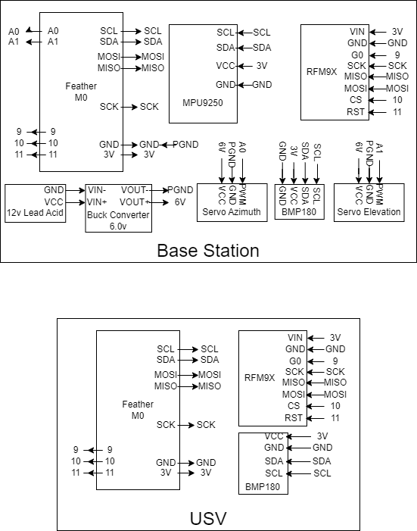

Figure IX. System Schematic

## System Design Methodology

To validate the effectiveness of our communication system, we conducted extensive tests and field trials. These evaluations were essential to assess real-world performance and identify any potential issues under typical marine conditions. This section outlines the methodology adopted, detailing the procedures and environments used to ensure a thorough and reliable assessment of our system’s capabilities.

### 3.4.1 Field Test Setup

Our field tests were designed to simulate the actual operational conditions of Unmanned Surface Vessels (USVs) in marine environments. The following components were integral to our setup:

1. **Base Station Configuration**:
   * Equipped with a dual-axis gimbal system to direct the directional antenna.
   * Utilized GPS and LoRa modules for accurate tracking and communication.
   * The setup was installed at a fixed coastal location to provide a stable reference point for all tests.
2. **USV Configuration**:
   * Outfitted with GPS and LoRa modules similar to the base station.
   * Included the necessary sensors and control systems to autonomously report its position and status back to the base station.

### 3.4.2 Test Procedures

The field tests were structured into several stages to evaluate different aspects of the system’s performance:

1. **Initial Alignment and Calibration**:
   * The base station and USV were positioned at known coordinates.
   * Initial calibration was performed to ensure the accuracy of the compass and the accelerometers on the base station.
   * This phase confirmed that the system components were functioning correctly and could establish a baseline for further tests.
2. **Range Testing**:
   * The USV was gradually moved away from the base station to determine the maximum effective communication range.
   * Throughout this process, continuous data was recorded on signal strength, data throughput, and connection stability.
3. **Dynamic Performance Evaluation**:
   * The USV was navigated along a pre-defined route featuring different maneuvers to simulate typical operational scenarios.
   * The base station’s tracking system was monitored to ensure it could maintain a stable connection with the moving USV.

### 3.4.3 Results and Observations

The field tests demonstrated that the communication system could effectively maintain a robust connection between the base station and the USV over extended distances. Key observations include:

1. **Enhanced Range:**
   * The directional antenna significantly improved the communication range compared to traditional omnidirectional systems.
   * Reliable data transmission was achieved at distances near the theoretical limits calculated in controlled simulations.
2. **Signal Stability:**
   * The system exhibited consistent signal strength, ensuring continuous data flow without significant interruptions.
   * Variations in environmental conditions, such as weather and sea state, had minimal impact on signal stability due to the robustness of the integrated systems.
3. **Latency and Throughput:**
   * The communication system maintained low latency, crucial for real-time data transmission and control of the USV.
   * High data throughput was consistently achieved, supporting the transmission of large datasets and real-time video feeds.
4. **Interference Resilience:**
   * The system demonstrated strong resilience to interference from other electronic devices and communication systems operating in the vicinity.
   * Adaptive frequency hopping and advanced error correction algorithms contributed to maintaining a clean and reliable communication channel.

# Chapter 4 – Future Work

The current project has laid a solid foundation for precise control and positioning, yet there are several avenues for improvement and expansion that could significantly enhance its capabilities. This chapter outlines potential future work, focusing on improving accuracy, expanding operational freedom, and overcoming existing limitations.

## 4.1 Implementation of Stepper Motors with Micro stepping

One of the primary enhancements involves replacing the current servo motors with stepper motors configured for micro stepping. Stepper motors offer several advantages over servos, particularly in terms of precision and control. Micro stepping allows stepper motors to achieve finer resolution by subdividing each step into smaller increments. Implementing a 1/256 step degree configuration can dramatically increase the system's accuracy.

### 4.1.1 Benefits of Stepper Motors

* **Higher Precision**: With micro stepping, the system can achieve angular resolutions down to fractions of a degree, providing much finer control over movements.
* **Improved Stability**: Stepper motors inherently hold their position better due to the nature of their design, reducing drift and improving repeatability.
* **Enhanced Load Handling**: Stepper motors are better suited for handling higher loads without compromising performance, which is beneficial for applications requiring robust positioning.

### 4.1.2 Technical Considerations

* **Driver Compatibility**: Ensuring that the selected stepper motors and micro stepping drivers are compatible with the existing control system.
* **Power Requirements**: Assessing and potentially upgrading power supplies to handle the increased demand from stepper motors.
* **Software Modifications**: Updating the control algorithms to accommodate the different operational characteristics of stepper motors.

## 4.2 Integration of RTK GPS for Enhanced Positioning Accuracy

To further improve the system's positional accuracy, integrating an RTK (Real-Time Kinematic) GPS module from Spark Fun is proposed. RTK GPS can significantly reduce positional errors, improving accuracy from approximately 1.8 meters to a radius of 400mm.

### 4.2.1 Advantages of RTK GPS

* **Higher Positional Accuracy**: RTK GPS can provide centimetre-level accuracy, which is crucial for applications requiring precise geographic positioning.
* **Real-Time Corrections**: The system can receive real-time corrections, improving dynamic accuracy during movement.

### 4.2.2 Implementation Steps

* **Hardware Integration**: Installing the RTK GPS module and ensuring it interfaces seamlessly with the existing system.
* **Data Processing**: Developing algorithms to process the high-precision data from the RTK GPS and integrate it into the control system.
* **Calibration and Testing**: Performing extensive calibration and testing to ensure the accuracy improvements are realized in practical scenarios.

## 4.3 Expanding Degrees of Freedom

The current system is limited to 180 degrees of freedom in both azimuth and elevation. This limitation can be addressed through the implementation of stepper motors, which offer the ability to rotate continuously and precisely.

### 4.3.1 Solving the 180-Degree Limitation

* **Continuous Rotation**: Stepper motors can rotate continuously without the constraints faced by servo motors, allowing for a full 360-degree range in both azimuth and elevation.
* **Increased Manoeuvrability**: Enhanced freedom of movement will enable the system to operate in a wider range of applications, such as panoramic imaging or full-sphere scanning.

### 4.3.2 Technical Challenges

* **Mechanical Design**: Modifying the mechanical design to accommodate continuous rotation without cable entanglement or mechanical interference.
* **Control System Updates**: Adapting the control software to handle the extended range of motion and ensuring smooth transitions across the entire operational range.

# Chapter 5 – Conclusions

This report investigated long-range communication solutions for Unmanned Surface Vessels (USVs) operating in marine environments, emphasizing the implementation of WiFi connectivity through private networks. The primary objectives were to explore suitable communication methods, evaluate their feasibility, and implement the solutions on a Raspberry Pi platform. The research highlighted the importance of robust communication networks for autonomous maritime systems, addressing existing knowledge gaps by exploring communication methodologies such as cellular networks, point-to-point (PTP) WiFi connections with directional antennas, and LoRa communication.

The study's findings underscored the effectiveness of using directional antennas for enhancing communication range and reliability. The implementation of a directional point-to-point link mounted on a dual-axis robotic arm, capable of tracking the USV at long distances using LoRa, demonstrated significant improvements in communication performance. The practical implications of these methodologies were validated through simulations, lab tests, and field trials, offering valuable insights into their effectiveness and reliability in marine environments.

## 5.1 Summary of Findings

### 5.1.1 Key Contributions

1. **Extended WiFi Connectivity:** The research validated the feasibility of extending WiFi connectivity for USVs through PTP WiFi connections using directional antennas. This approach significantly improved the communication range and signal stability, addressing the inherent challenges of USV communication in marine environments.
2. **Innovative Antenna Tracking System:** The implementation of a dual-axis robotic arm for antenna control demonstrated a robust solution for maintaining stable long-range communication. This system effectively tracked the USV's position, ensuring continuous and reliable data transmission.
3. **Integration of LoRa Communication:** By incorporating LoRa communication, the study highlighted its potential for providing long-range, low-power communication, complementing the WiFi-based primary communication link. This integration enhanced the overall reliability and redundancy of the communication system.
4. **Comprehensive Evaluation Methodology:** The research employed a rigorous validation and evaluation methodology, including simulations, lab tests, and field trials. This comprehensive approach ensured a thorough assessment of the proposed communication solutions, providing practical insights into their performance in real-world marine settings.

### 5.1.2 Limitations

Despite the promising results, several limitations were identified that need to be addressed in future research:

1. **GPS Spoofing:** The reliance on GPS for positioning introduces a vulnerability to GPS spoofing attacks. Spoofing can deceive the USV by providing false positional data, potentially leading to navigation errors or loss of the vessel. Future work should incorporate robust GPS spoofing detection and mitigation techniques, such as signal authentication and cross-referencing multiple navigation systems.
2. **RF Jamming:** The communication links, particularly those relying on WiFi and LoRa, are susceptible to RF jamming attacks. Jamming can disrupt the communication between the USV and the base station, causing loss of control and data transmission. Implementing advanced anti-jamming techniques, such as frequency hopping, spread spectrum, and adaptive filtering, can enhance the resilience of the communication system against such attacks.
3. **Environmental Interference:** Marine environments pose challenges such as signal reflection, diffraction, and absorption by water and atmospheric conditions. These factors can degrade communication performance, particularly over long distances. Further research should focus on optimizing antenna designs and exploring alternative frequency bands to mitigate environmental interference.

# Chapter 6 – Appendix

## 6.1 Resources and Tools

This chapter provides a comprehensive list of all hardware and software resources utilized in the research and implementation of long-range communication solutions for Unmanned Surface Vessels (USVs) in marine environments. For further details and access to the resources, please refer to the GitHub repository at the following link: [GitHub Repository](https://github.com/Deathwalker9959/tracking-antenna).

# References

|  |  |
| --- | --- |
| [1] | B.-C. Min, E. Matson and J.-W. Jung, “Active Antenna Tracking System with Directional Antennas for Enhancing Wireless Communication Capabilities of a Networked Robotic System”. |
| [2] | S. Pensieri, F. Viti, G. Moser, S. B. Serpico, L. Maggiolo, M. Pastorino, D. Solarna, A. Cambiaso, C. Carraro, C. Degano, I. Mainenti, S. Seghezza and R. Bozzano, “Evaluating LoRaWAN Connectivity in a Marine Scenario”. |
| [3] | F. S. Alqurashi, A. Trichili, N. Saeed, B. S. Ooi and M.-S. Alouini, “Maritime Communications: A Survey on Enabling Technologies, Opportunities, and Challenges,” *IEEE Internet of Things Journal,* 2022. |
| [4] | M. Hoeft, K. Gierlowski, J. Rak, J. Wozniak and K. Nowicki, “Non-Satellite Broadband Maritime Communications for e-Navigation Services,” *IEEE Access,* 2021. |
| [5] | SpaceX, “Starlink Specifications,” Starlink, [Online]. Available: https://www.starlink.com/specifications. [Accessed 11 09 2023]. |
| [6] | W. Contributors, “5G,” 08 06 2019. [Online]. Available: https://en.wikipedia.org/wiki/5G. [Accessed 11 09 2023]. |
| [7] | HUAWEI TECHNOLOGIES CO., LTD., “5G Power Whitepaper,” HUAWEI, 2019. |
| [8] | P. Riihikallio, “8 reasons to turn down the transmit power of your Wi-Fi,” 21 10 2017. [Online]. Available: https://metis.fi/en/2017/10/txpower/. [Accessed 12 09 2023]. |
| [9] | Lora Alliance, “What Is LoRaWAN® Specification,” Lora Alliance, 2023. [Online]. Available: https://lora-alliance.org/about-lorawan/. [Accessed 12 09 2023]. |
| [10] | PCMAG, “Is Starlink Good for Gaming? We Put SpaceX's Satellite Service to the Test,” [Online]. Available: https://www.pcmag.com/news/is-starlink-good-for-gaming-we-put-spacexs-satellite-service-to-the-test. [Accessed 12 09 2023]. |
| [11] | Verizon, “What is the Latency of 5G?,” [Online]. Available: https://www.verizon.com/about/our-company/5g/5g-latency. [Accessed 12 09 2023]. |
| [12] | C. McGarry, “5G Speed: 5G vs 4G Performance Compared,” Tom's Guide, 28 10 2019. [Online]. Available: https://www.tomsguide.com/features/5g-vs-4g. [Accessed 12 09 2023]. |
| [13] | “A Guide to Mobile Download Speeds: 2G, 3G, 4G and 5G. What Do They Actually Mean?,” [Online]. Available: https://www.tigermobiles.com/faq/mobile-download-speed-guide/. [Accessed 12 09 2023]. |
| [14] | A. Pötsch and F. Hammer, “Towards End-to-End Latency of LoRaWAN: Experimental Analysis and IIoT Applicability,” *IEEE Xplore,* 01 05 2019. |
| [15] | M. Sheetz, “SpaceX prices Starlink satellite internet service at $99 per month, according to e-mail,” CNBC, [Online]. Available: https://www.cnbc.com/2020/10/27/spacex-starlink-service-priced-at-99-a-month-public-beta-test-begins.html#:~:text=SpaceX%20prices%20Starlink%20satellite%20internet%20service%20at%20%2499. [Accessed 12 09 2023]. |
| [16] | J. Padden, “A Little LTE for You & Me: Build Your Own LTE Network on a Budget,” CableLabs, 14 11 2017. [Online]. Available: https://www.cablelabs.com/blog/a-little-lte-for-you-me-build-your-own-lte-network-budget. [Accessed 12 09 2023]. |
| [17] | Tutorialspoint, “Antenna Theory - Isotropic Radiation,” [Online]. Available: https://www.tutorialspoint.com/antenna_theory/antenna_theory_isotropic_radiation.htm. [Accessed 19 09 2023]. |
| [18] | J. Gil, “IEEE Transactions on Antennas,” *IEEE Transactions on Antennas and Propagation,* vol. 60, 08 2012. |
| [19] | Everything RF, “What Is a Yagi Antenna?,” 2021. [Online]. Available: https://www.everythingrf.com/community/what-is-a-yagi-antenna. [Accessed 19 09 2023]. |
| [20] | D.-H. Lee, H.-S. Lee, S.-M. Hwang and J.-W. Ahn, “Design of an Impulse Radiating Antenna Using a Curved TEM-Wire Fed Parabola,” *International Journal of Antennas and Propagation,* vol. 2012, 01 01 2012. |
| [21] | SEMTECH, “SX1276-7-8 Datasheet,” [Online]. Available: https://cdn-shop.adafruit.com/product-files/3179/sx1276_77_78_79.pdf. |